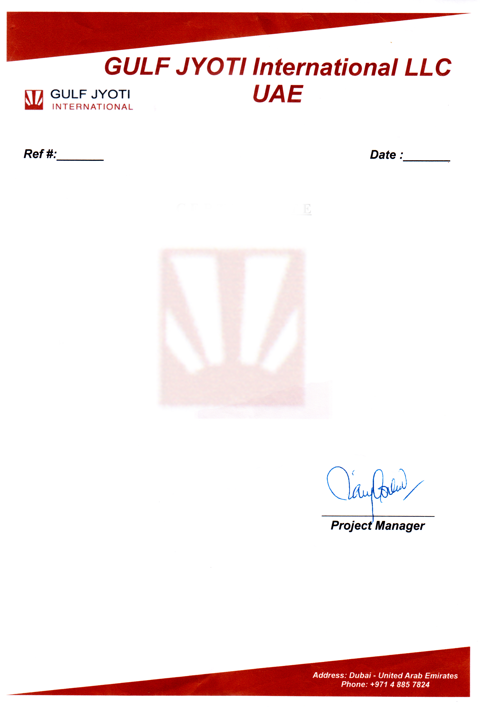

GYI&142/ <To2>

C E R T I F I C A T E

It is certified that Mr. <Name> S/O Mr. <fname> worked with us <Designation> at Gulf Jyoti International LLC UAE from <From2> to <To2>.

In the tenure of his service we found him hard working and having vast experience in this field.

We wish him every success in his life.